**Instruction Testing for R-Type and I-Type Instruction**

|  |  |  |  |
| --- | --- | --- | --- |
| Serial Number | Testbench Name | Problem Name | Instructions |
| 1 | core_tb_1 | ADD | addi, add |
| 2 | core_tb_2 | SUB | addi, sub |
| 3 | core_tb_3 | SLL | addi, sll |
| 4 | core_tb_4 | SRL | addi,srl |
| 5 | core_tb_5 | SRA | addi,sra |
| 6 | core_tb_6 | SLT | addi,slt |
| 7 | core_tb_7 | SLTU | addi,sltu |
| 8 | core_tb_8 | OR | addi,or |
| 9 | core_tb_9 | AND | addi,and |
| 10 | core_tb_10 | XOR | addi,xor |
| 11 | core_tb_11 | SLTI | addi,slti |
| 12 | core_tb_12 | SLTUI | addi,sltui |
| 13 | core_tb_13 | XORI | addi,xori |
| 14 | core_tb_14 | ORI | addi,ori |
| 15 | core_tb_15 | ANDI | addi,andi |
| 16 | core_tb_16 | SLLI | addi,slli |
| 17 | core_tb_17 | SRLI | addi,srli |
| 18 | core_tb_18 | SRAI | addi,srai |

**RESULTS**

* **ADD**

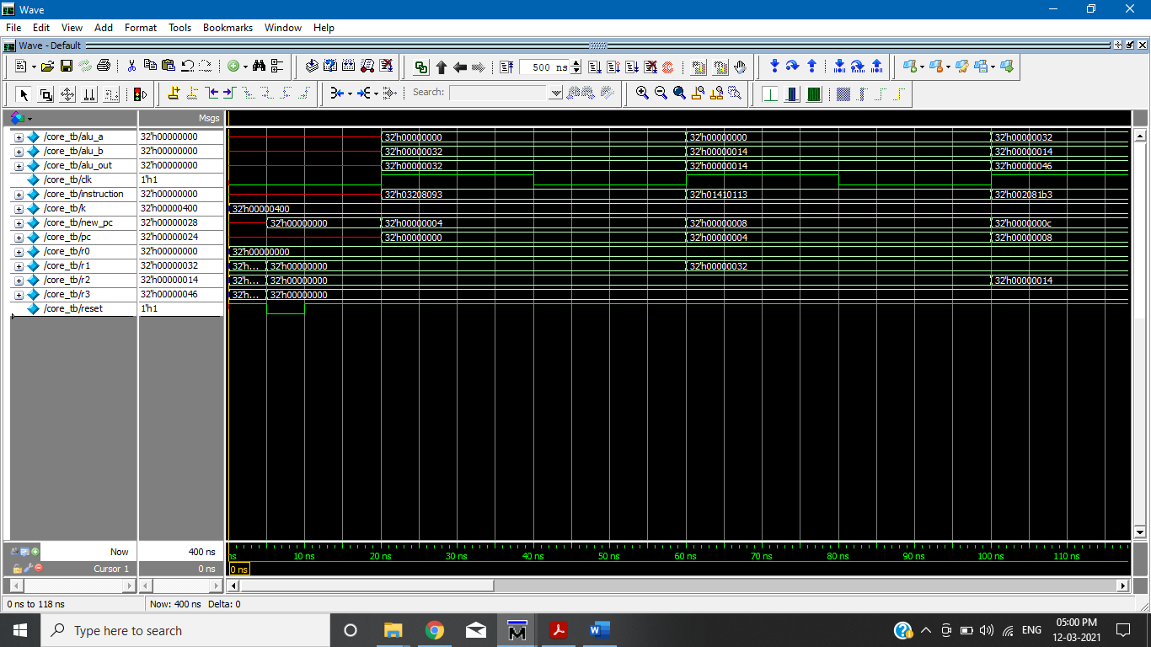

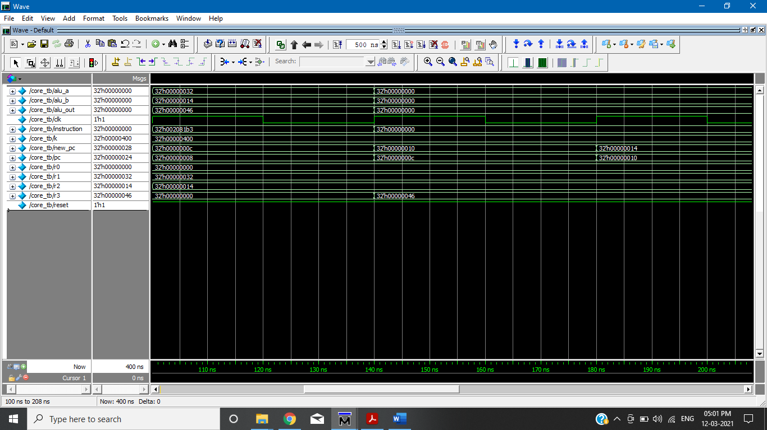

* **SUB**

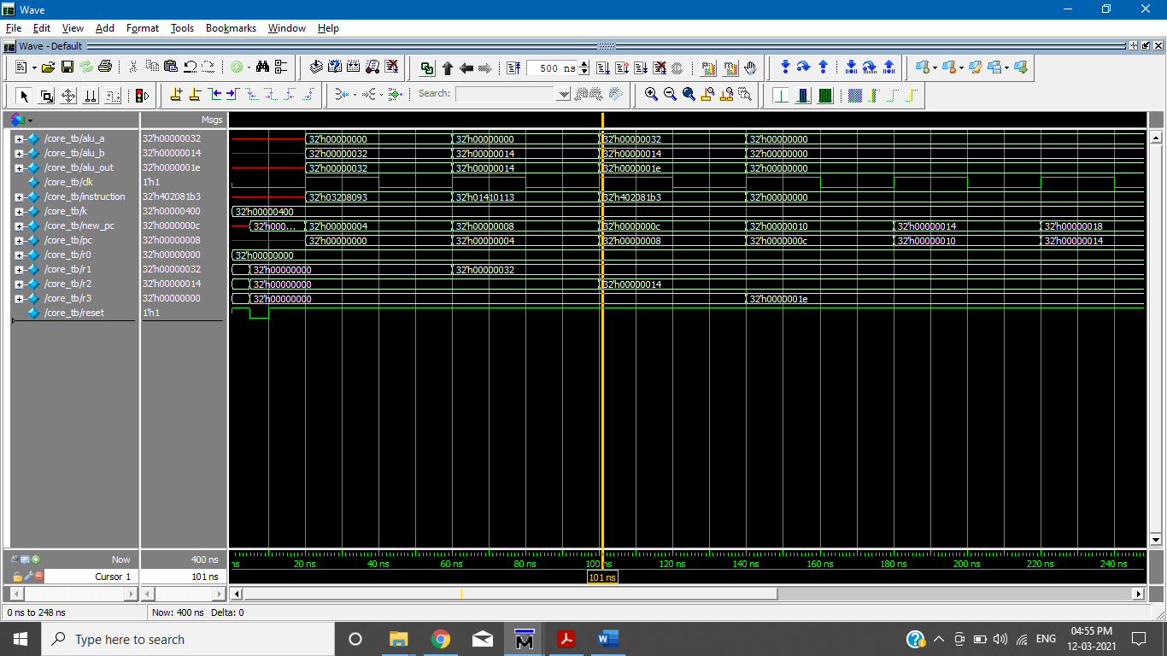

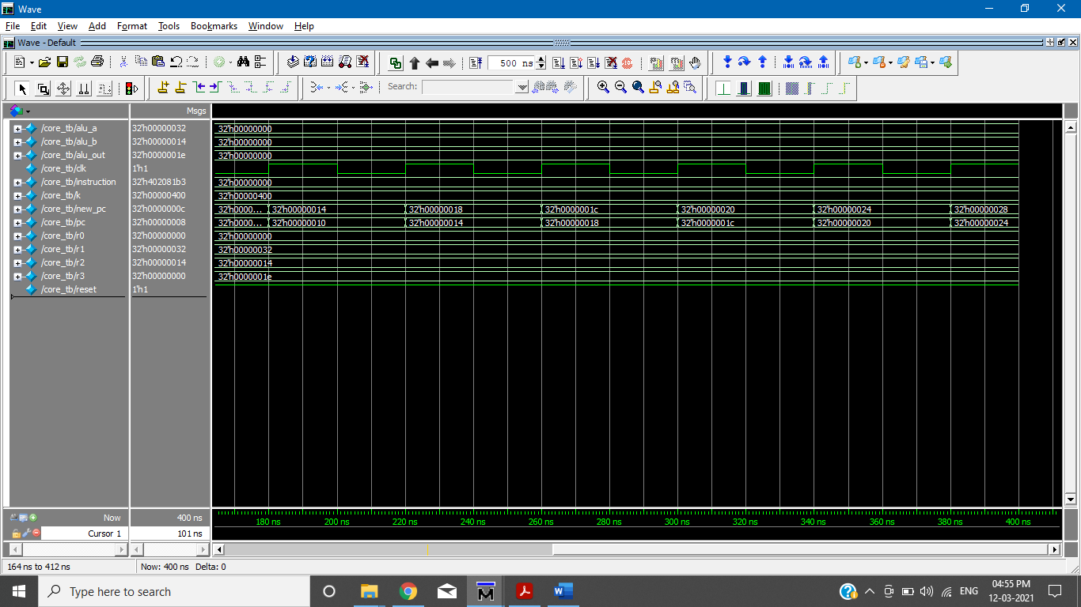

* **SLL**

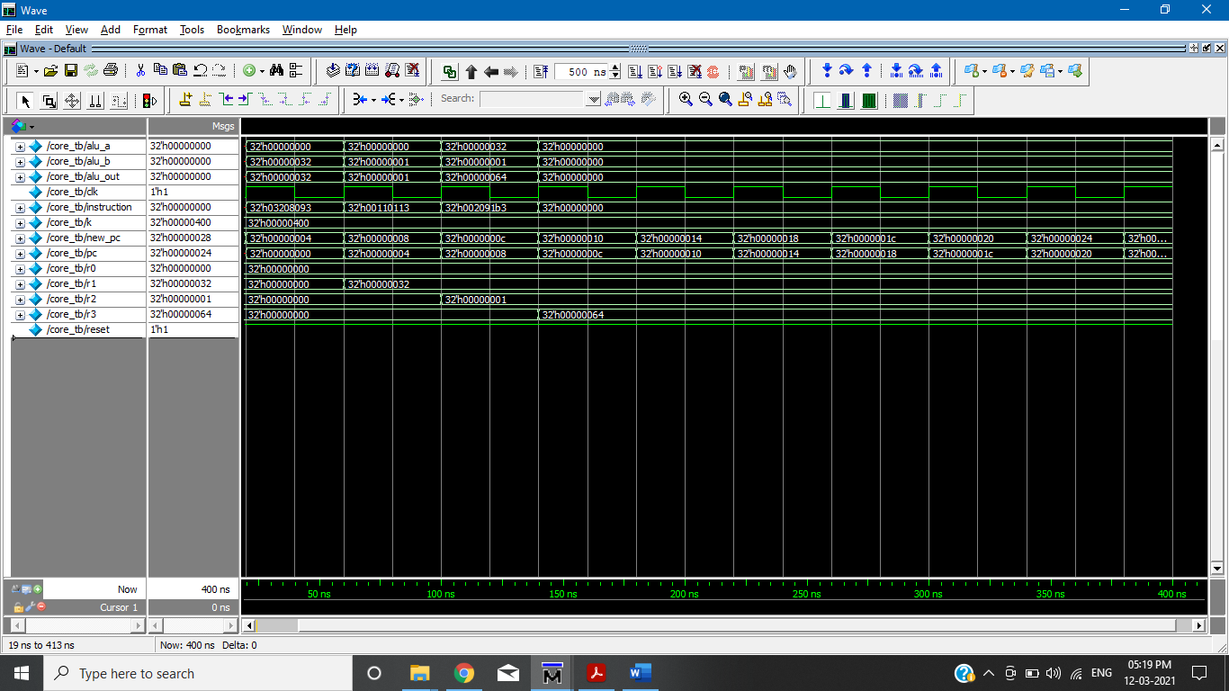

* **SRL**

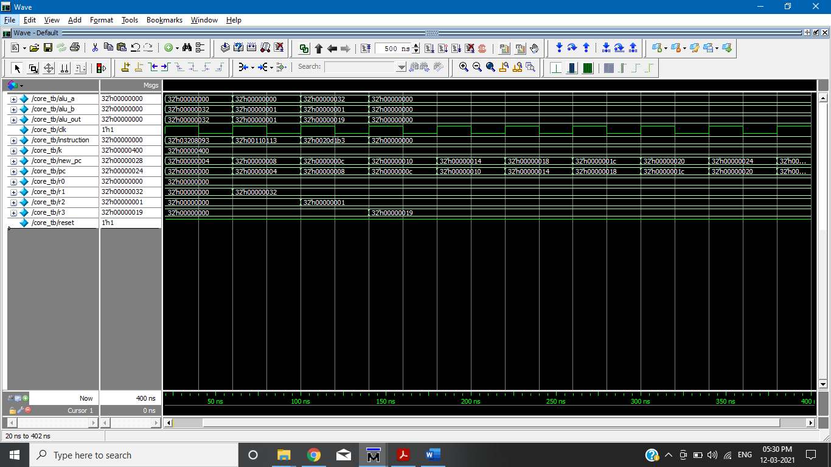

* **SRA**

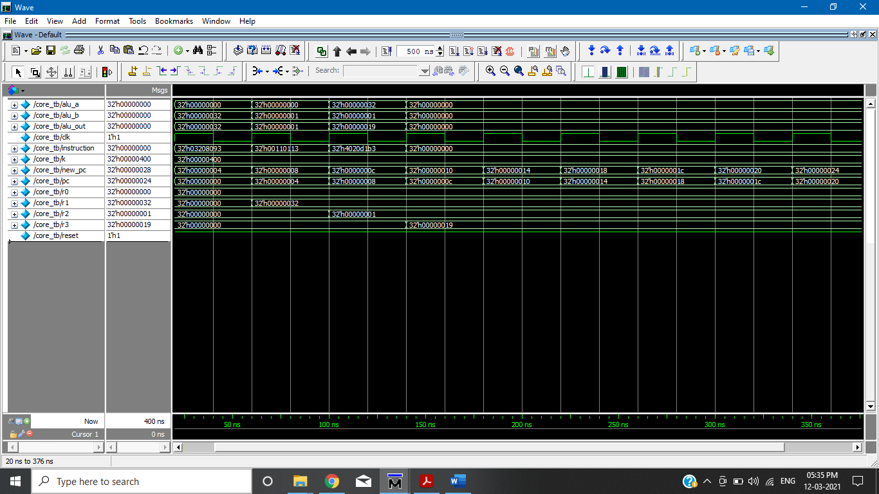

* **SLT**

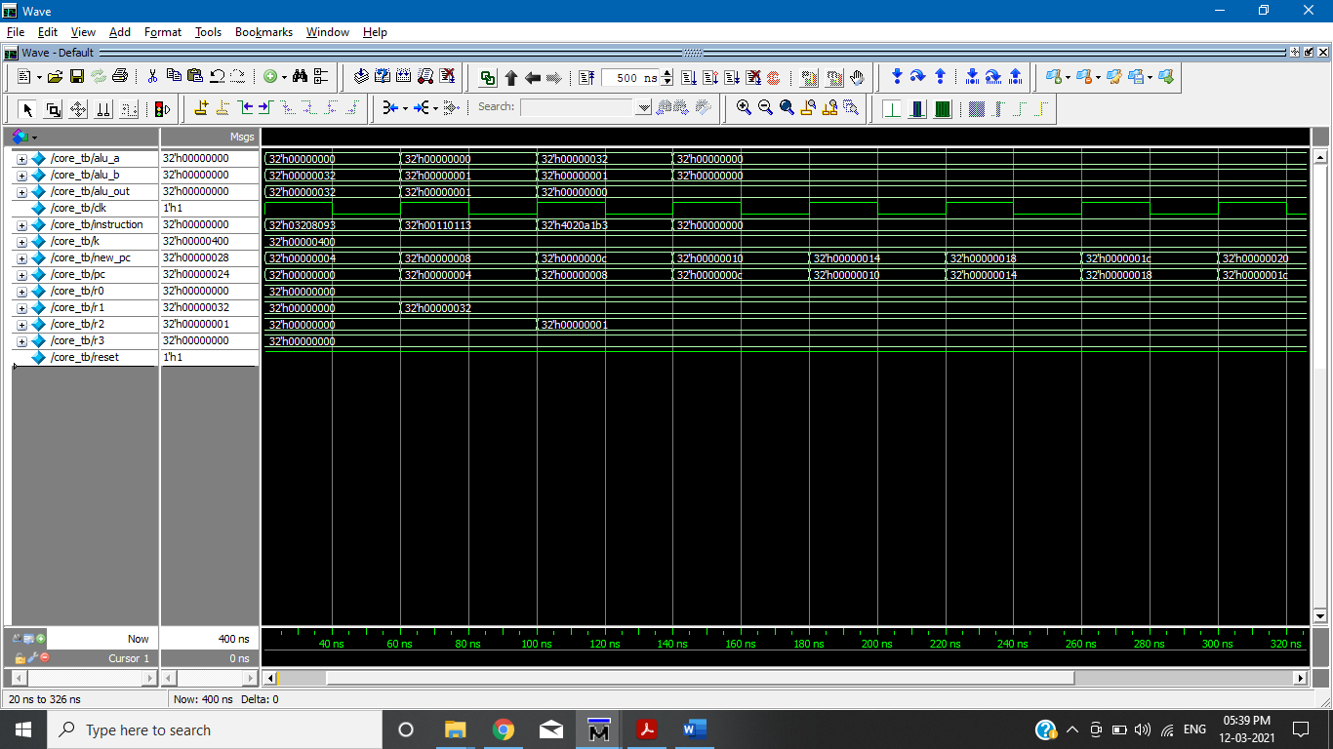

* **SLTU**

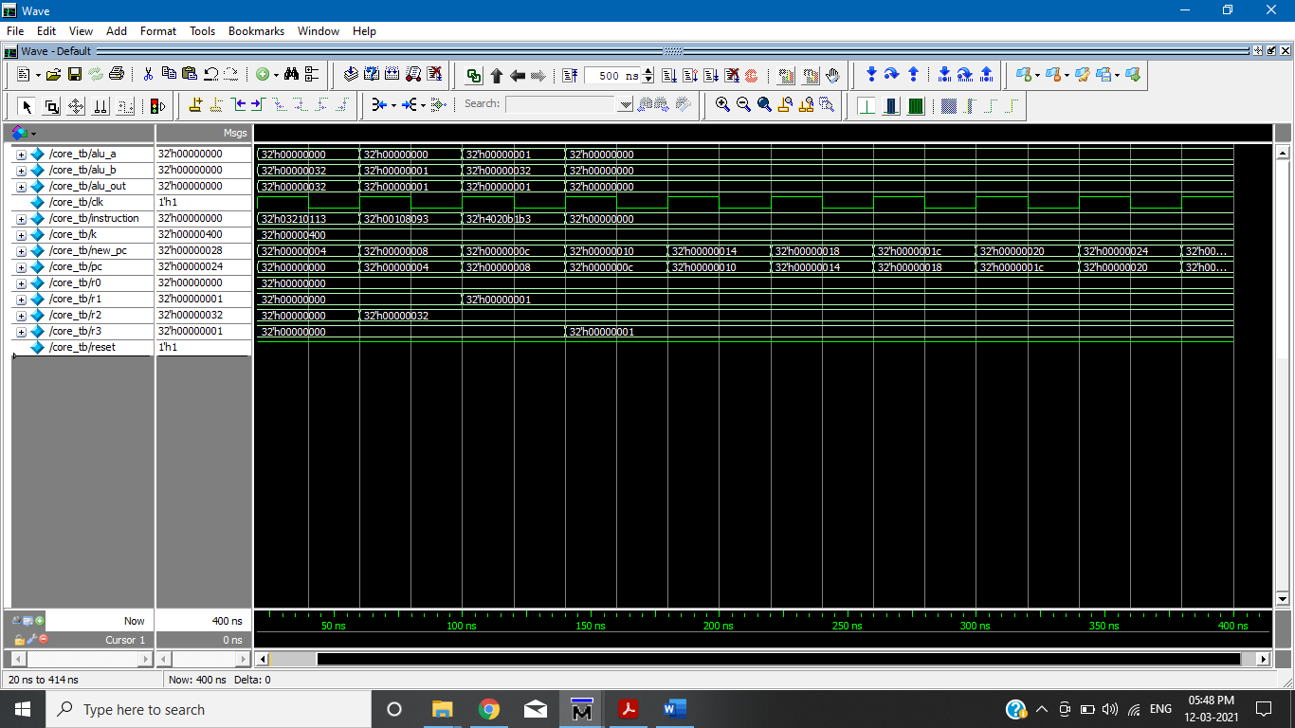

* **OR**

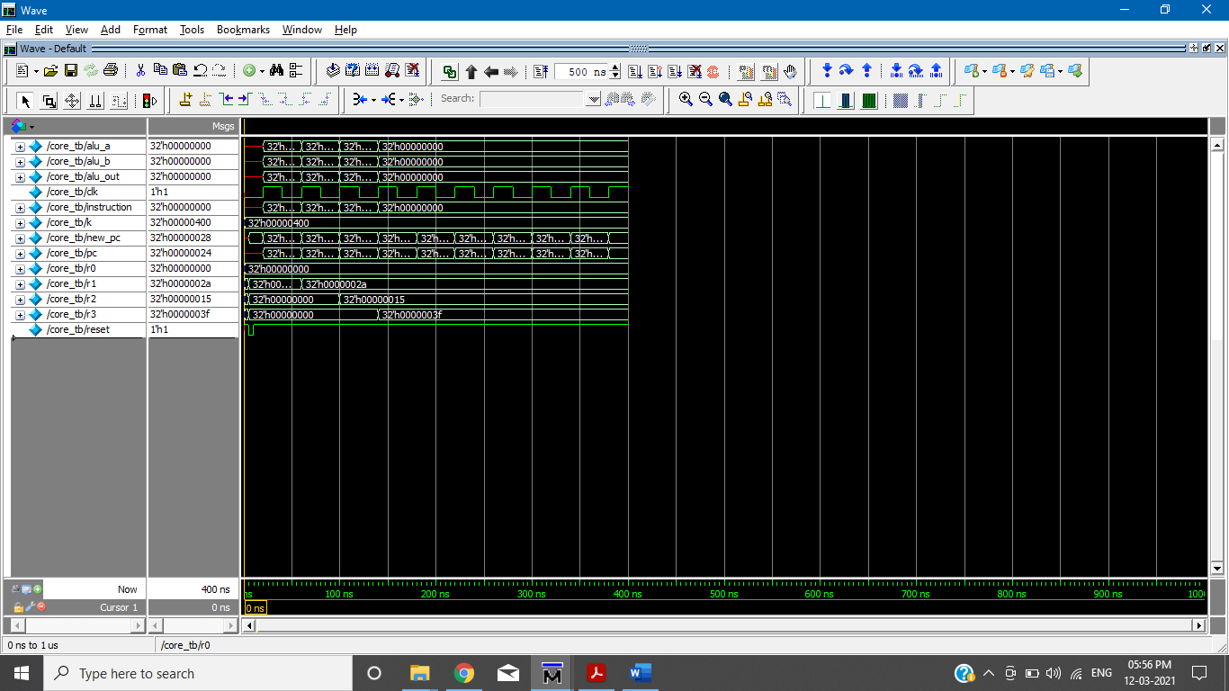

* **AND**

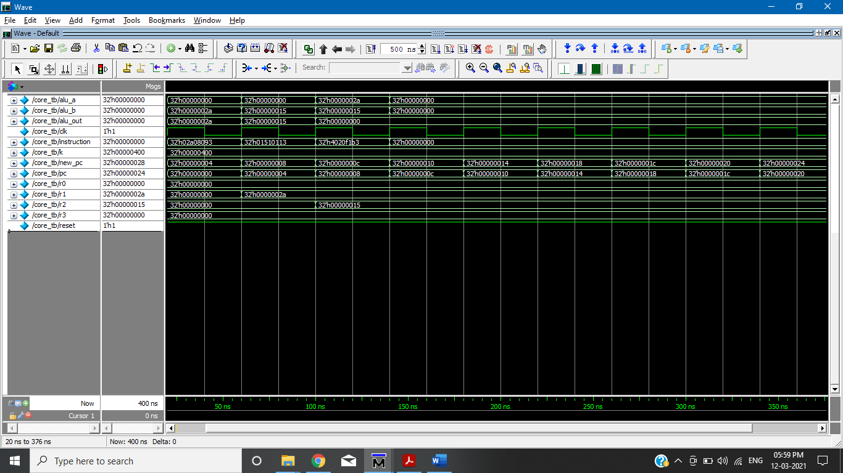

* **XOR**

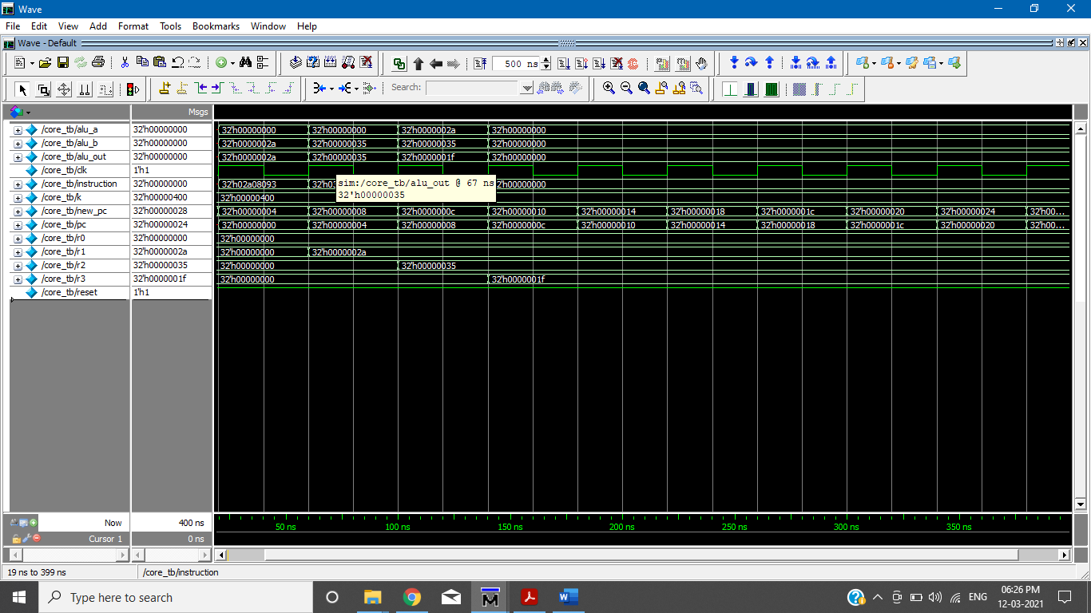

* **SLTI**

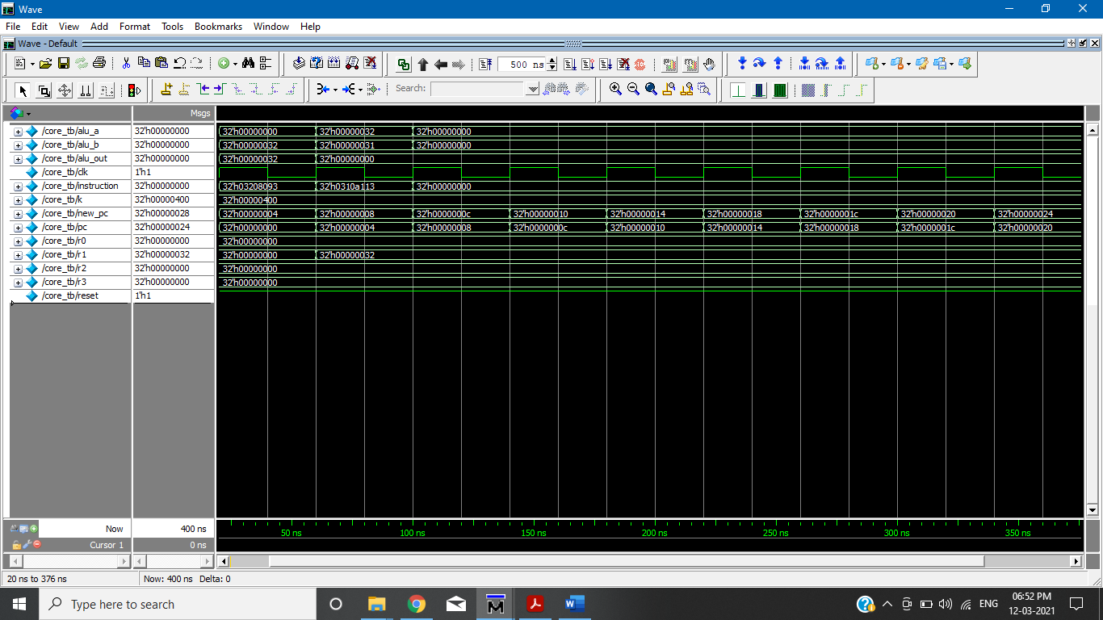

* **SLTUI**

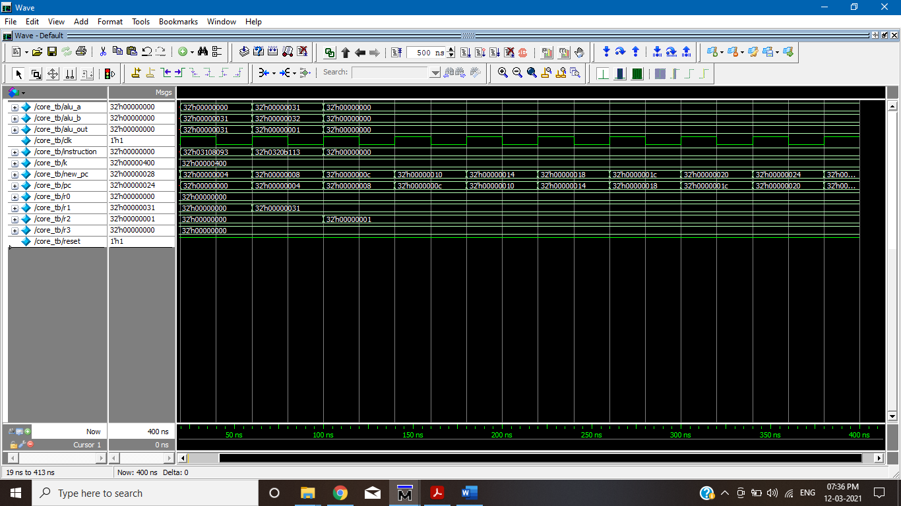

* **XORI**

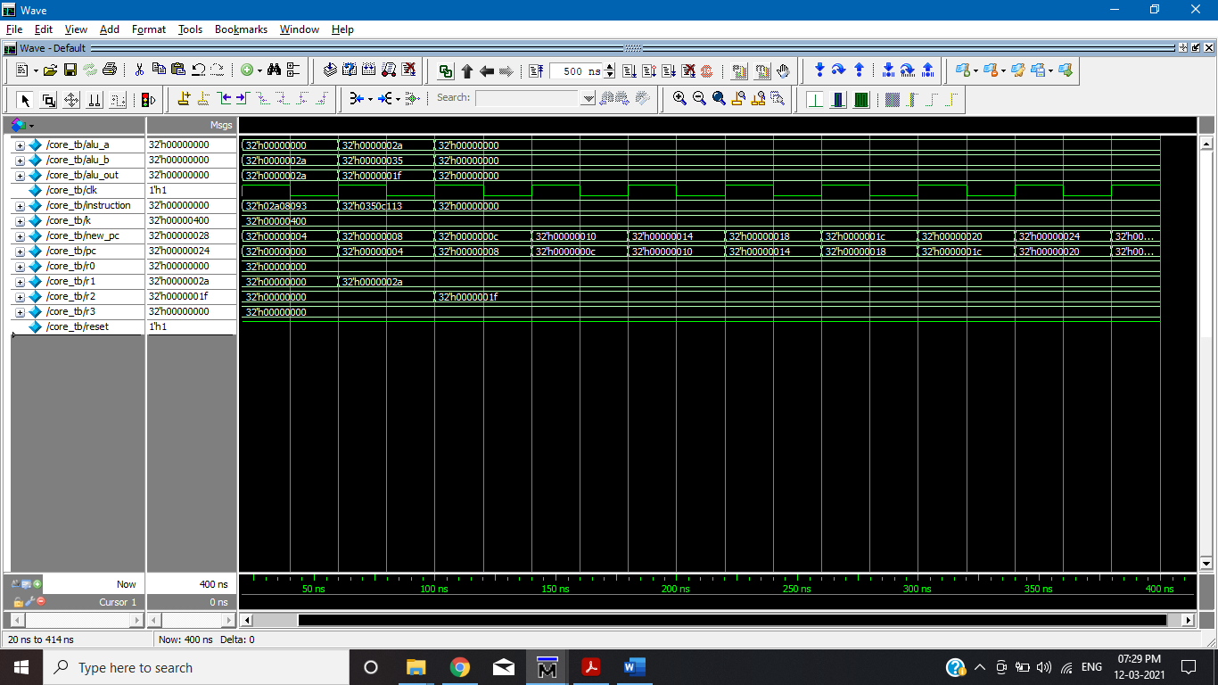

* **ORI**

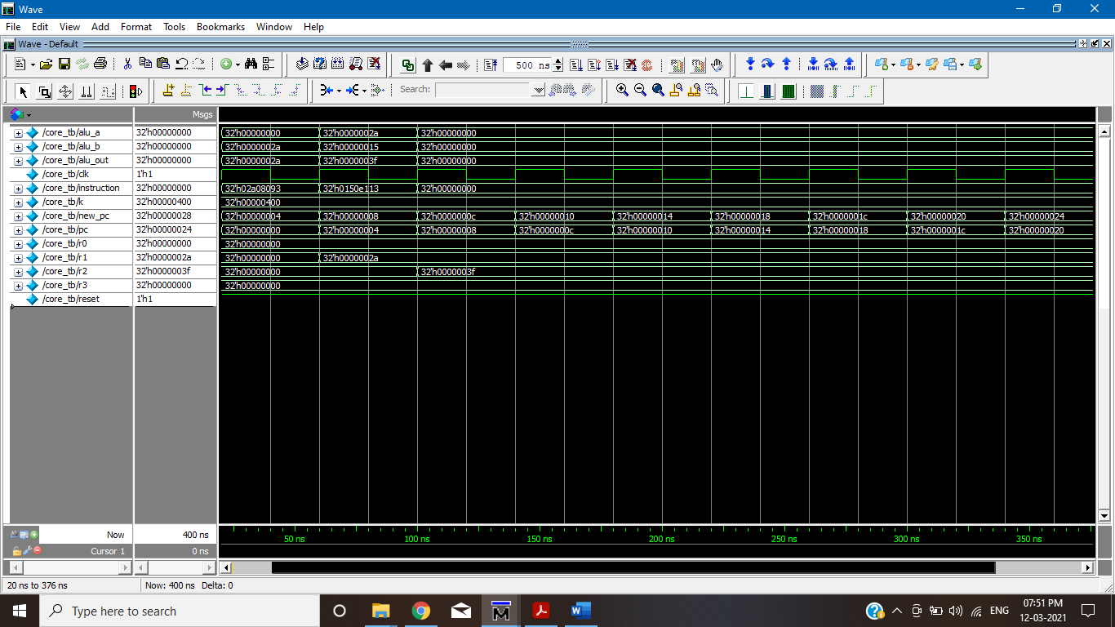

* **ANDI**

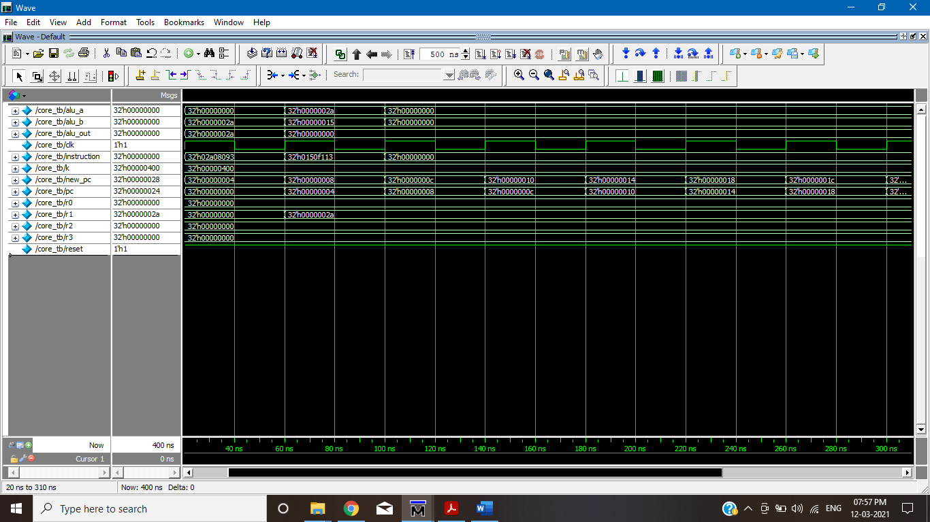

* **SLLI**

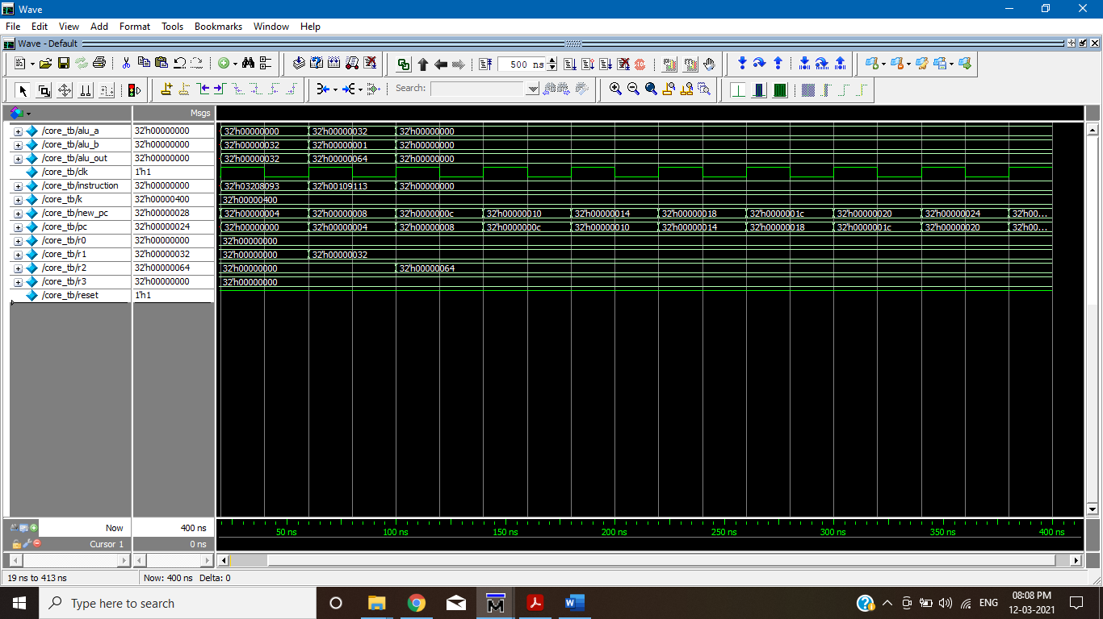

* **SRLI**

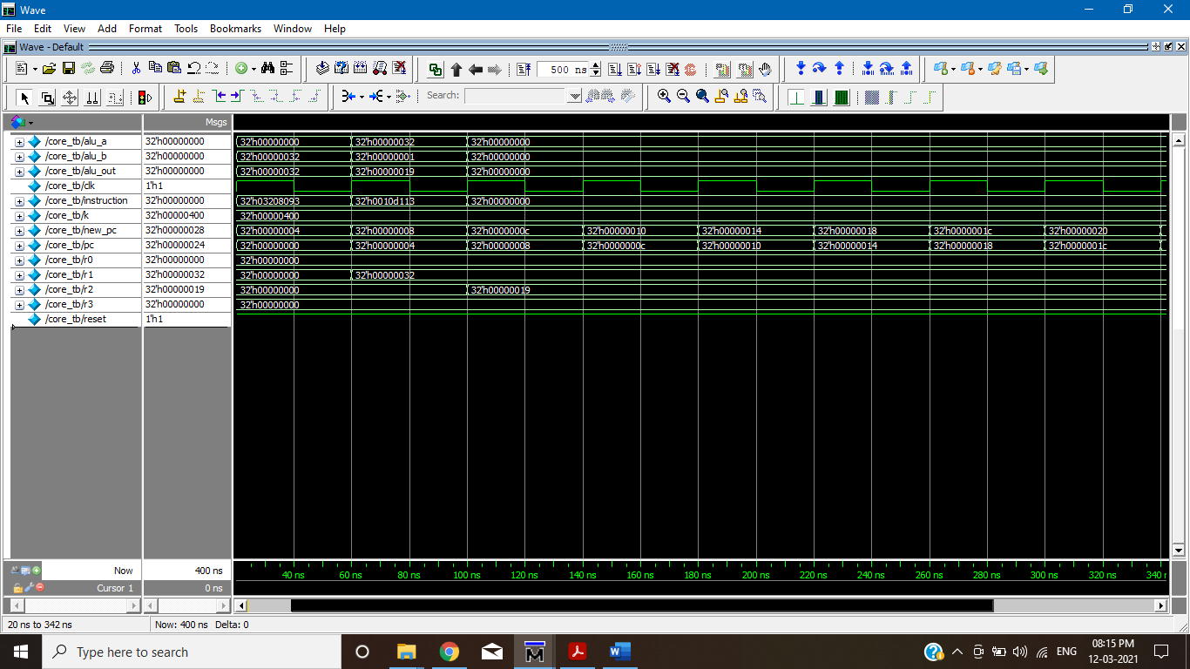

* **SRAI**

